



Kenya Natural Capital Accounts for Forests

Draft 1

January 2026

Table of Contents
List of Figures and Tables 4
Acronyms 5
Glossary 8
Foreword 10
Executive Summary 13
1. Introduction 14
1.1. Introduction 14
1.2. Background Information 14
1.3. Importance of Forest Accounts (Purpose and objectives) 15
1.4 The institutional and policy context for forest accounts 15
1.4.1. Constitution of Kenya 2010 15
1.5. Forest in Kenya 21
1.5.1 Kenya’s Geographical and Forest Ecological Context 21
2. Methodology 26
a. Introduction 26
b. Land cover data and their sources 26
c. Emission factors for biomass assessment 27
d. Forest volumes in public plantations 27
e. Food resources from the forest 27
f. Developing Supply and Use tables for wood products 28
3. Asset Accounts for Forests 29
3.1 Forest Assets in Kenya 29
3.1.1 Forest Cover Trends and Status (1990–2024) 29
3.1.2. Forest Assets by strata 31
3.1.3. Spatial Distribution of Forest Assets by County 32
3.2. Forest Opening and Closing Stocks 36
3.3 Forest Biomass and Volume Stocks 37
3.3.1. Volumes of standing wood 37
3.3.4. Forests as Food sources 40
4. Supply and Use Tables 41
a. Physical Supply and Use Table 41
b. Monetary Supply and Use Tables 44
c. Timber and Non-timber Forest Products Physical and Monetary Flow Account (PFA) 44
d. Scenario Analysis 44
5. Conclusions & Emerging Issues 45
6. Annexes 47

List of Figures and Tables

Acronyms
AFR100 African Forest Landscape Restoration Initiative
CFAs Community Forest Associations
DRSRS Department of Resource Surveys and Remote Sensing
EO Earth Observation
GDP Gross Domestic Product
GPS Global Program on Sustainability (World Bank)
ICBT Informal Cross-Border Trade
IPCC Intergovernmental Panel on Climate Change
ISIC International Standard Industrial Classification
KENMOD Kenya Macroeconomic Model
KEFRI Kenya Forestry Research Institute
KFS Kenya Forest Service
Kgs Kilograms
KNBS Kenya National Bureau of Statistics
Ksh Kenya Shillings
LCLU Land Cover and Land Use
m³ Cubic Meter
MoECCF Ministry of Environment, Climate Change & Forestry
NDC Nationally Determined Contributions
NPAEEA National Plan for Advancing Environmental Economic Accounting
NTFPs Non-Timber Forest Products
NPV Net Present Value
PES Payment for Ecosystem Services
PFA Physical Flow Account
PSUT Physical Supply and Use Table
QGIS Quantum Geographic Information System
REDD+ Reducing Emissions from Deforestation and Forest Degradation
R-Studio Statistical computing and graphics software (based on R)
SDGs Sustainable Development Goals
SEEA System of Environmental-Economic Accounting
SEEA CF System of Environmental-Economic Accounting – Central Framework
SEEA EA System of Environmental-Economic Accounting – Ecosystem Accounting
SLEEK System for Land-based Emissions Estimation in Kenya
SNA System of National Accounts
SUT Supply and Use Table
TJ Terajoules
TWG Technical Working Group
UNSD United Nations Statistics Division
WB World Bank

Glossary

Carbon Sequestration: The process by which forests and other ecosystems capture and store carbon dioxide from the atmosphere.
Ecosystem Accounting: A statistical framework (SEEA EA) that measures ecosystems as assets, tracking their extent, condition, and the services they provide.
Ecosystem Services: The contributions of ecosystems to economic and human activity, such as air purification or water regulation, which enable people to derive benefits like clean air and safe water.
Exchange Value: The monetary value that goods or services would fetch in a real or hypothetical market, used in SEEA-based accounts.
Forestland: Is a land area of more than 0.5ha, with at least canopy cover of at least 15%, trees of minimum 2m height in situ, which is not primarily under agricultural or other specific non-forest land use.
Forest Asset Account: An account that records the opening and closing stock of forest resources, along with changes due to natural growth, removals, and degradation.
Forest Ecosystem Asset: The stock of natural forest ecosystems, valued as the net present value of expected future service flows.
Forest Ecosystem Services: Services provided by forests, such as timber, carbon sequestration, water regulation, recreation, and habitat maintenance.
Green GDP: Gross Domestic Product adjusted for environmental degradation and depletion of natural resources.
Market Price Principle: The use of observable market prices, or their proxies, to value goods and services for consistency with the SNA.
Monetary Accounts: Accounts that assign monetary values to stocks and flows of environmental assets and services, making them comparable to traditional economic accounts.
Net Present Value (NPV): The discounted sum of expected future benefits, expressed in today’s monetary terms.
Non-Timber Forest Products (NTFPs): Products derived from forests that are not timber, such as honey, fruits, medicinal plants, and resins
Physical Flow Account (PFA): An account that tracks the supply and use of natural resource flows and residuals in physical units (e.g., tonnes, cubic meters).
Physical Supply and Use Table (PSUT): A tabular framework recording physical flows of goods, services, and residuals between the environment and the economy.
Provisioning Services: The material products provided by ecosystems, such as timber, fuelwood, and food.
Raster Data: Gridded spatial data where each cell (pixel) has a value representing a land cover type or other variable; commonly used in satellite-based mapping.
Regulating Services: The contributions of ecosystems that regulate ecological processes, such as climate regulation, flood control, or air and water purification, which support human well-being and economic activity.
Remote Sensing: The use of satellite or airborne sensors to collect information about the Earth’s surface without physical contact, widely used in land cover and land use monitoring.
SEEA (System of Environmental-Economic Accounting): An international statistical standard for integrating environmental and economic data
SEEA Central Framework (SEEA CF): The core SEEA standard, focusing on individual environmental assets and flows, consistent with the SNA.
SEEA Ecosystem Accounting (SEEA EA): An extension of the SEEA that includes ecosystem extent, condition, and services
SLEEK: System for Land-based Emissions Estimation in Kenya (SLEEK) is a national program that was designed to estimate emissions using medium-resolution imagery (Landsat) from land cover change maps (1990-2018).
System of National Accounts (SNA): The internationally agreed standard set of recommendations on how to compile measures of economic activity in accordance with strict accounting conventions based on economic principles (SNA, 2008). The SNA provides a comprehensive and detailed record of the complex economic activities taking place within an economy and of the interaction between the different economic agents, and groups of agents, that takes place on markets or elsewhere (SNA, 2008).
Social Discount Rate: A lower discount rate used for public policy to give greater weight to future generations’ benefits.
Spatial Disaggregation: The process of breaking down data to smaller geographic units (e.g., counties or sub-counties) to support localised analysis and decision-making.
Supply and Use Table (SUT): A table that shows the supply of products from domestic production and imports and their use by industries, households, and exports, in monetary terms.
Technical Working Group (TWG): A multi-agency body responsible for the coordination, development and validation of natural capital accounts, such as those for land, water or ecosystems.
Welfare Value: The broader value of goods and services, including consumer surplus, beyond their market value (not used in SEEA accounts).

Foreword
The Kenya National Bureau of Statistics (KNBS) is pleased to present the report on Kenya's Natural Capital Accounts for Forests, developed in collaboration with the State Department for Economic Planning and our development partners. This report represents a significant milestone in Kenya's efforts to integrate environmental sustainability into economic planning and decision-making. Forests constitute a critical component of Kenya's natural capital, providing essential ecosystem services including water regulation, carbon sequestration, biodiversity conservation, and livelihoods for millions of Kenyans. Despite their importance, the true value of forests and the services they provide have remained largely invisible in our national economic accounts.
This report follows the internationally recognized System of Environmental-Economic Accounting (SEEA) framework, adopted by the United Nations Statistical Commission, thus ensuring Kenya's forest accounts are not only scientifically robust but also internationally comparable. The development of the forest accounts builds on Kenya's pioneering work in Environmental-Economic Accounting that began in 2017 with a pilot report on Energy accounts. Over time, the Bureau has progressively expanded the natural capital accounting framework across water, energy, land, ecosystems, and forests. The formal adoption of the National Plan for Advancing Environmental-Economic Accounting (NP-AEEA) 2025-2028, in July 2025, established a clear national roadmap for institutionalizing natural capital accounting across the six priority sectors.
The findings of this report have direct relevance for Kenya's national development priorities. The forest accounts provide critical inputs for our Vision 2030 development blueprint and the Bottom-Up Economic Transformation Agenda. They support our commitments under international frameworks, including the Sustainable Development Goals, the Paris Agreement on Climate Change, and the Global Biodiversity Framework.
The analysis also establishes a clear link between forest conservation and broader economic outcomes. The integration of these forest accounts into Kenya's macro-fiscal modeling through the enhanced Kenya Macroeconomic and Fiscal Model (KENMOD) allows us to quantify the macroeconomic impacts of climate shocks on forests and to assess the benefits and trade-offs of green fiscal measures and forest restoration investments. As such, strengthening the evidence base for aligning fiscal policy with climate and environmental objectives. The report further provides insights aimed at strengthening forest management and governance in Kenya.
As we implement the NP-AEEA over the coming years, these forest accounts will be produced regularly, enabling us to track progress and ensure accountability in natural resource governance. This regular reporting cycle will also provide opportunities for continuous refinement of methodologies, enhancement of data quality, and strengthening of institutional technical capacity as implementation of the natural capital accounting framework advances. It is our hope that this report will serve as a resource for policymakers, researchers, and stakeholders as we collectively work toward achieving sustainable forest management and environmental stewardship.

Macdonald George Obudho, PhD, EBS, MBS
DIRECTOR GENERAL
KENYA NATIONAL BUREAU OF STATISTICS

Acknowledgements:
This report is the product of a collaborative effort between the Kenya National Bureau of Statistics (KNBS), the State Department for Economic Planning, Kenya Forest Service and Kenya Forestry Research Institute (in the State Department of Forestry, Ministry of Environment, Climate Change and Forestry) and our development partners. I extend my sincere appreciation to all the teams and individuals whose invaluable contributions made this work possible.

The State Department for Economic Planning, under the leadership of Principal Secretary Dr. Bonface Makokha, has been instrumental in championing the institutionalization of natural capital accounting in Kenya and ensuring alignment with national development priorities. The formation of the National Steering Committee has ensured high-level coordination across government agencies.

I acknowledge the Kenya National Bureau of Statistics (KNBS) for the leadership and technical support throughout the development of this report. I wish to applaud the KNBS Directors, notably Mr. Robert Nderitu .…. , for their dedicated leadership in constituting the technical working group, validation of the findings of the study, as well as for their technical guidance and encouragement throughout the entire report preparation process. I extend special thanks .

I acknowledge tireless efforts of the members of the technical committee in consolidating data and write up of the document.

Executive Summary

Dr. Kinyanjui

Introduction

1.1. Introduction
Forests are a vital part of Kenya’s natural capital, supporting the economy, climate resilience, and livelihoods. They provide goods such as timber, fuel wood, honey, and medicinal plants, which are critical for both formal industries and household needs. Forests also deliver essential ecosystem services — including carbon sequestration, water regulation, soil erosion control, and cultural and recreational opportunities — that sustain agriculture, energy, biodiversity, and human well-being. These contributions make forests central to Kenya’s sustainable development agenda and its national and international commitments, including Vision 2030, the Nationally Determined Contributions (NDCs), and the AFR100 restoration initiative.
Despite this importance, forests remain undervalued in Kenya’s official statistics. Conventional accounts, based on the System of National Accounts (SNA), recognize only a limited set of marketed products like timber and charcoal, overlooking the wider ecosystem services that forests provide. This gap in measurement can lead to decisions that underestimate the economic and social costs of deforestation and the benefits of restoration and sustainable management.
This document introduces the internationally recognized System of Environmental-Economic Accounting (SEEA) as a framework for compiling more comprehensive forest accounts. It explains the concepts, structure, and policy relevance of SEEA forest accounts, describes the current data situation in Kenya, and identifies steps toward developing physical, monetary, and ecosystem accounts for forests.

1.2. Background Information
Kenya has recently developed and adopted a National Plan for Advancing Environmental Economic Accounts (NPAEEA). The plan describes the conditions which make it critical to account for natural capital in a way that it is congruent with sustainable economic development and national planning. The plan, the first draft of which was conceived during a collaborative effort between the Kenya National Bureau of Statistics (KNBS) and the United Nations Statistics Division (UNSD) to develop environmental-economic accounts for Kenya in September 2023,^{[1]} identified as priority Water, Energy, Land, Forest and Ecosystem Accounts.
This technical report provides an overview of the development of Forest Accounts in Kenya. It begins with an introduction to the context, objectives, and significance of SEEA-aligned Forest Accounting within the broader framework of Kenya’s development plan. It then outlines the data sources and methodology used. The report proceeds to explain how national and county-level Forest Accounts were compiled and analyzed, followed by a presentation of key empirical results, in tables and graphics, including maps. The report also discusses current gaps in monetary and ownership accounts, before offering recommendations to improve technical methods, institutional coordination, and policy relevance.

1.3. Importance of Forest Accounts (Purpose and objectives)
- Forest accounting addresses key gaps in national statistics by integrating biophysical and economic data. It enables better monitoring of forest resources, supports sustainable management, and informs climate, development, and restoration policies. Forest accounting complements conventional macro-economic statistics by making the full value of forests visible to decision-makers. Consequently, SEEA provides standardized and internationally accepted methods, ensuring comparability and consistency.
- Forest accounting provides a systematic way to measure and report on the extent, condition, and use of forest resources — capturing both physical and monetary aspects. It supports a broad set of policy, management, and planning goals, including:
- Monitoring and managing natural capital: Forest accounts should provide a clear picture of how forest assets contribute to national wealth and how these assets change over time.
- Integrating environmental and economic data: Accounts should align biophysical data (e.g., forest area, harvested timber) with economic measures (e.g., value of timber output), enabling better-informed decisions.
- Improving data coherence: By using common classifications and accounting principles, forest accounts should overcome the fragmentation typical of standalone environmental datasets.
- Correcting the limitations of GDP: Traditional accounts often omit forest degradation and the value of non-market services such as carbon storage or erosion control.
- Supporting SDG and climate targets: Forest accounts contribute to monitoring SDG 15.2 (sustainable forest management) and global frameworks like REDD+ and the Global Biodiversity Framework.
- Identifying opportunities for job creation in sustainable forestry, restoration, and eco-tourism.

1.4 The institutional and policy context for forest accounts
The Forest accounts is anchored in the Constitution, sector laws, policy and guidelines as well as International Multilateral agreements. Key relevant policy, legislative and regulatory framework for NCA in Kenya is reviewed below.

1.4.1. Constitution of Kenya 2010
The Preamble of the Constitution provides that the people of Kenya shall be RESPECTFUL of the environment, which is our heritage, and determined to sustain it for the benefit of future generations. Chapter 5 on land and environment article 60 outlines principles of land policy upon which natural capital stocks are entrenched while article 69 places obligation on the state to ensure sustainable exploitation, utilization, management, and conservation of the environmental and natural resources with equitable sharing of the accruing benefits. Further the Land Act 2012 provides the guiding values and principles of land management and administration where principle (c) is on sustainable and productive management of land resources, and (e) is on conservation and protection of ecologically sensitive areas.
In the advancement of the national effort in the achievement of SDGs, natural capital accounting plays a key role towards attainment of the targets set for Goal 15: Protect, restore, and promote sustainable use of terrestrial ecosystems, sustainably manage forests, combat desertification, and halt and reverse land degradation and halt biodiversity loss). Some of the Goal 15 targets are:
· ensure the conservation, restoration and sustainable use of terrestrial and inland freshwater ecosystems and their services, in particular forests, wetlands, mountains, and drylands, in line with obligations under international agreements promote the implementation of sustainable management of all types of forests, halt deforestation, restore degraded forests and substantially increase afforestation and reforestation globally combat desertification, restore degraded land and soil, including land affected by desertification, drought and floods, and strive to achieve a land degradation-neutral world.
· take urgent and significant action to reduce the degradation of natural habitats, halt the loss of biodiversity and protect and prevent the extinction of threatened species
· promote fair and equitable sharing of the benefits arising from the utilization of genetic resources and promote appropriate access to such resources, as internationally agreed
· integrate ecosystem and biodiversity values into national and local planning, development processes, poverty reduction strategies and accounts
· mobilize and significantly increase financial resources from all sources to conserve and sustainably use biodiversity and ecosystems
· mobilize significant resources from all sources and at all levels to finance sustainable forest management and provide adequate incentives to developing countries to advance such management, including for conservation and reforestation
· enhance global support for efforts to combat poaching and trafficking of protected species, including by increasing the capacity of local communities to pursue sustainable livelihood opportunities.

The Forest Act (Cap 385)
The Forest Conservation and Management Act, enacted in 2016, is designed to give effect to Article 69 of the Kenyan Constitution regarding the sustainable management of forest resources. It aims to ensure the conservation and rational utilization of forests for socio-economic development while protecting the environment and biodiversity.The Act applies to all forests on public, community, and private lands, ensuring comprehensive coverage of forest management practices. The Act emphasizes good governance, public participation, community involvement, and adherence to international best practices in forest management. The Act mandates the preparation of management plans for all public forests, which outline the goals and practices necessary for sustainable forest management.

Community participation is entrenched within the Act encouraging community involvement in forest management through community forest associations, allowing local communities to participate in decision-making processes related to forest resources. It provides for protection of indigenous forests and the sustainable use of forest resources, ensuring that local ecosystems are preserved. The Act regulates the trade of forest products, ensuring that such activities are conducted sustainably and legally.
The Forest Conservation and Management Act 2016 is a significant legislative framework aimed at promoting sustainable forest management in Kenya. By establishing clear guidelines and encouraging community participation, the Act seeks to balance ecological integrity with socio-economic development, ensuring that forest resources are preserved for future generations.

Relevant Multilateral Environmental Agreements (MEAs)
Kenya is signatory to several international conventions and treaties that would need to be adhered to in implementing this project and are geared towards environmental protection and conservation. Biodiversity-related conventions form an important cluster, including most of the key global conventions including but not limited to the outlined below:
The Convention on Biological Diversity (CBD-1992)
Kenya signed the CBD in 1992 and ratified it on 26th July 1994. Article 14 of the CBD (Impact Assessment and Minimizing Adverse Impacts) calls on signatory states to take measures to prevent the degradation of systems that support biodiversity. Specifically, it calls upon party states to act as follows as far as possible and as appropriate:
· introduce appropriate procedures requiring environmental impact assessment and audits of its proposed or ongoing projects that are likely to have significant adverse effects on bio-logical diversity with a view to avoiding or minimizing such effects and, where appropriate, allow for public participation in such procedures.
· introduce appropriate arrangements to ensure that the environmental consequences of its programs and policies that are likely to have significant adverse impacts on biological diversity are duly considered.
· promote, on the basis of reciprocity, notification, exchange of information and consultation on activities under their jurisdiction or control which are likely to significantly affect adversely the biological diversity of other States or areas beyond the limits of national jurisdiction, by encouraging the conclusion of bilateral, regional or multilateral arrangements, as appropriate.

Convention Biological Diversity (CBD): Aichi Target 5
By 2020, the rate of loss of all natural habitats, including forests, is at least halved and where feasible brought close to zero, and degradation and fragmentation is significantly reduced. This proposed framework takes into consideration the CBD objectives of conservation of biodiversity, sustainable use of its components the fair and equitable sharing of the benefits arising out of utilization of the genetic resources. Keeping in mind that habitat loss is the most important factor driving biodiversity loss especially degradation and fragmentation due to land use change. Thus, the rate of change needs to be substantially reduced in Kenya.

The Convention concerning the Protection of the World Cultural and Natural Heritage (1972)
This Convention focuses on the concepts of nature conservation and the preservation of cultural properties. The Convention recognizes the way in which people interact with nature, and the fundamental need to preserve the balance between the two. By signing the Convention, each country pledges to conserve not only the World Heritage sites situated on its territory, but also to protect its national heritage. The proposed framework seeks to enhance the protection of our natural heritage.

The United Nations Convention to Combat Desertification (UNCCD)
The above UN Convention was signed at Paris on 17th June 1994and entered into force in December 1996. Its key objective is to combat desertification and mitigate the effect of serious drought, particularly in Africa, through international support. It obligates developed countries who are members to fully consider the special needs of affected developing countries. The Convention goes further to enlist action programmes, scientific and technical co-operation and supporting measures to be put in place. It contributes to distinguishing causal factors, both natural and human, with a view to combating desertification and achieving improved productivity as well as the sustainable use and management of resources. The proposed framework will ensure that there are components focusing on mitigating the effect of the negative effects that may enhance desertification in the ecologically sensitive ecosystem in the vast dryland area.

The Global Strategy for Plant Conservation (GSPC)
The Global Strategy for Plant Conservation began as a grass-roots movement in 1999. The ultimate and long-term objective of the GSPC is to halt within targeted timelines the current and continuing loss of plant diversity. Importantly, this strategy attempts to understand, document, and recognize plant diversity, urgently and effectively conserve it in a sustainable and equitable manner. It also creates awareness about plant diversity role in sustainable livelihoods promoting its importance, developing capacities and public engagement.

The Global Strategy for Plant Conservation is a catalyst for working together at all levels - local, national, regional, and global to understand, conserve and use sustainably the world's immense wealth of plant diversity whilst promoting awareness and building the necessary capacities for its implementation. The proposed framework seeks to ensure that ecologically sensitive areas are not negatively affected but are conserved with enhanced sustainable use of their immense wealth of biodiversity.

National Land Use Policy 2014
The policy provides a framework for optimal utilization and productivity of land related resources in a sustainable and desirable manner at National, County and Community level:
· Section 2.5.7 recognizes nature reserves and human settlement as among the various land uses in Kenya hence need for planned use of land and its resources, measures for equitable and sustainable utilization for optimal production.
· Section 2.5.8 emphasizes on the rationalization of human settlement development plan to cater for optimal utilization of land and other natural resources within and around settlements both in rural and urban areas.
· Section 2.6.10 on sectoral land use conflicts provides the following measures
o identification, mapping and gazetting of critical wildlife migration and dispersal corridors in consultation with the local communities and individual landowners
o encouraging development of wildlife sanctuaries and conservancies and involving local communities living in contiguous to the parks and protected and protected areas in the co-management of such areas.
o providing mechanism for resolving grievances arising from human/wildlife conflict
o reviewing the gazettement of forests and protected areas to foster the realization of their multiple value and ensuring that they are protected for their ecosystem value and not merely to physically exclude human activities

· Section 3.1 gives highlights on the procedure for the allocation of land and issuance of title which should be done based on approved Physical Development Plan and approved Survey plans, approved local areas zoning regulations and policy guidelines. It also recognizes that allocation of public land identified to have high public value like wildlife habitat will not be allocated except under leases with conditions that reflect the high value or period by which the land may be required for a reserved use.

· Section 3.1. (ix) shows that areas protected for specific use by any law shall not be de-gazettement except in circumstances prescribed in the laws governing such areas. It further says that the protection of land rights of illegally occupied lands shall be pursued through litigation by the owners.
· Section 3.8 and 3.14 discusses more on the orderly management of land such as Biodiversity conservation which include mapping of wildlife corridor, planning, securing wildlife dispersal and migratory corridors through provision of easement and fiscal incentives programs to the affected communities or individuals.

National Spatial Plan (NSP) (2015-2045)
The policy document defines the general trend and direction of spatial development of the country. The Plan provides national physical planning policies aimed at guiding micro level physical development plans. Section 2.8.1 categorizes land use into three parts: agricultural, built-up areas (human settlement) and conservation including wildlife.

· Section 3.3.2 on Environmental conservation emphasizes that environmentally sensitive areas such as parks or reserves should be prioritized and highly protected from threats which are because of human activities in the form of land use practices. The NSP strategy in ranking of the environmentally sensitive areas in terms of impacts placed parks and conservancies under rank 2 and proposed only permission to controlled development of hotels and no change of user to any other use is not permitted except for conservation purposes.

· NSP Policies and measures on tourism diversification (Section 4.6) proposes the following:

o wildlife migratory corridors to be protected,
o location of incompatible land use activities to be prohibited
o developments within the tourist attraction sites to be strictly regulated and Protection of wildlife watering points.

The reason why policies on land and natural resources places emphasis on wise use is to preserve the biodiversity and ecosystem services that support other economic sectors that are easily determined fiscally. Langat et al (2017) made a comprehensive review on policies and legal framework from the Constitution 2010, Policies, Acts of parliament, regulations and guidelines and county ordinances.

1.5. Forest in Kenya

1.5.1 Kenya’s Geographical and Forest Ecological Context
Kenya is an equatorial country in East Africa covering approximately 59 million hectares, with a highly diverse physical environment that strongly influences the distribution and characteristics of its forest ecosystems. Forests occur along a broad altitudinal and ecological gradient, from coastal mangroves at sea level to montane forests in the highlands, including Mount Kenya at 5,199 metres above sea level. The Great Rift Valley plays a central role in shaping forest patterns by influencing rainfall, drainage, and ecological transitions across the country.
Kenya’s forested highlands form the core of its hydrological system, with most of the country’s six major drainage basins originating in these areas. Key forested catchments, often referred to as water towers, including the Mau Forest Complex, Mount Kenya, the Aberdares, Mount Elgon, and the Cherangany Hills, are essential for regulating water flows and sustaining hydropower generation, irrigation, urban water supply, and downstream ecosystem services.

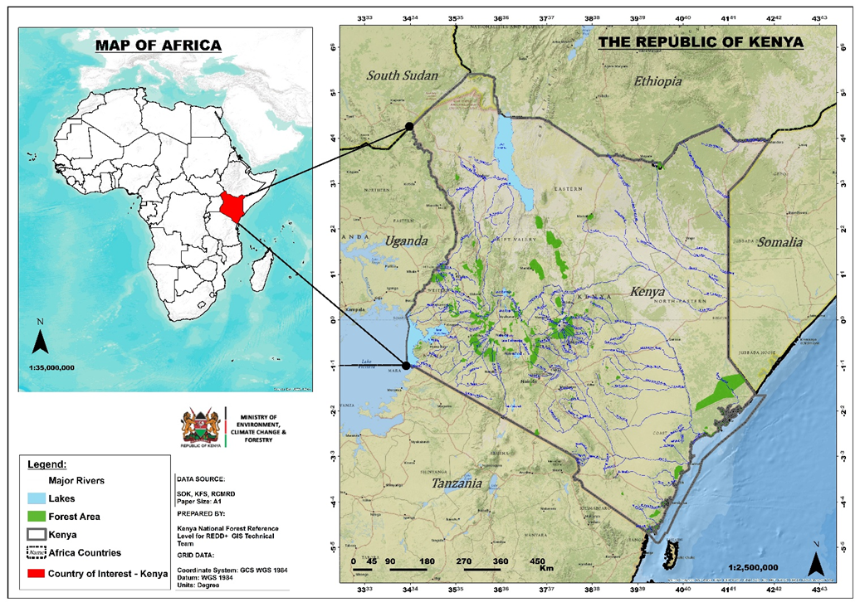
Figure 1: Geographical Location of Kenya
1.5.2 National Forest and Tree Definitions
The national definition of forests in Kenya adopted from the FAO guidelines and includes a land unit exceeding 0.5 hectares, with a minimum canopy cover of 15% and trees capable of reaching at least 2 meters in height in situ. This definition includes trees, bamboos, mangroves, palms, and fruit trees but excluded non-woody species such as bananas, shrubs, and shrubby crops like coffee and tea.

1.5.3 Forest Stratification Types
Kenya’s forest estate is categorized into six distinct strata, reflecting both ecological characteristics and management objectives. Five strata are derived from broad ecological zones, aligned with the Intergovernmental Panel on Climate Change (IPCC) classification, while the sixth is defined by commercial management. The Forest Strata:
- Montane Forests: Situated above 1,500 meters, these "Water Towers" (e.g., Mau, Mt. Kenya, Aberdares) are critical for catchment protection. Species vary by microclimate, ranging from windward moist broad-leafed forests to leeward dry coniferous forests and high-altitude bamboo (Oldeania alpina).
- Western Rain Forests: Characterized by Guineo-Congolean traits, these forests (e.g., Kakamega and Nandi) feature significantly larger and taller trees than other Kenyan strata.
- Coastal Forests: Located within 30 km of the shoreline, these biodiversity hotspots include the Arabuko-Sokoke and Tana River complexes, dominated by Combretum and Brachystegia woodlands.
- Mangrove Forests: Saline-adapted ecosystems featuring several species (e.g., Rhizophora mucronata, Avicennia marina). They follow distinct zonation patterns and are vital for protection of costal shorelines and their ecosystems.
- Dryland Forests: Found in Arid and Semi-Arid Lands (ASALs), these are dominated by Acacia-Commiphora species. Their unique deciduous nature and rooting systems differentiate their biomass dynamics from those of moist forests.
- Public Plantation Forests: Established for commercial production across various ecological zones.
  - Public Plantations: Managed by the Kenya Forest Service (KFS) across 152,790 hectares, primarily consisting of even-aged monocultures (Cupressus lusitanica, Eucalyptus, and Pinus species).

Table 1: Kenya’s classification of forest by strata
Forest strata | Canopy Cover Definitions
Montane Forests | Dense (Canopy cover % ≥65%)
 | Moderate (≥40 Canopy cover % <65)
 | Open (≥15 Canopy cover % <40)
Western-Rain Forests | Dense (Canopy cover % ≥65%)
 | Moderate (≥40 Canopy cover % <65)
 | Open (≥15 Canopy cover % <40)
Coastal Forests | Dense (Canopy cover % ≥65%)
 | Moderate (≥40 Canopy cover % <65)
 | Open (≥15 Canopy cover % <40)
Mangrove Forests | Dense (Canopy cover % ≥65%)
 | Moderate (≥40 Canopy cover % <65)
 | Open (≥15 Canopy cover % <40)
Dryland Forests | Dense (Canopy cover % ≥65%)
 | Moderate (≥40 Canopy cover % <65)
 | Open (≥15 Canopy cover % <40)
Plantation | Public Plantations

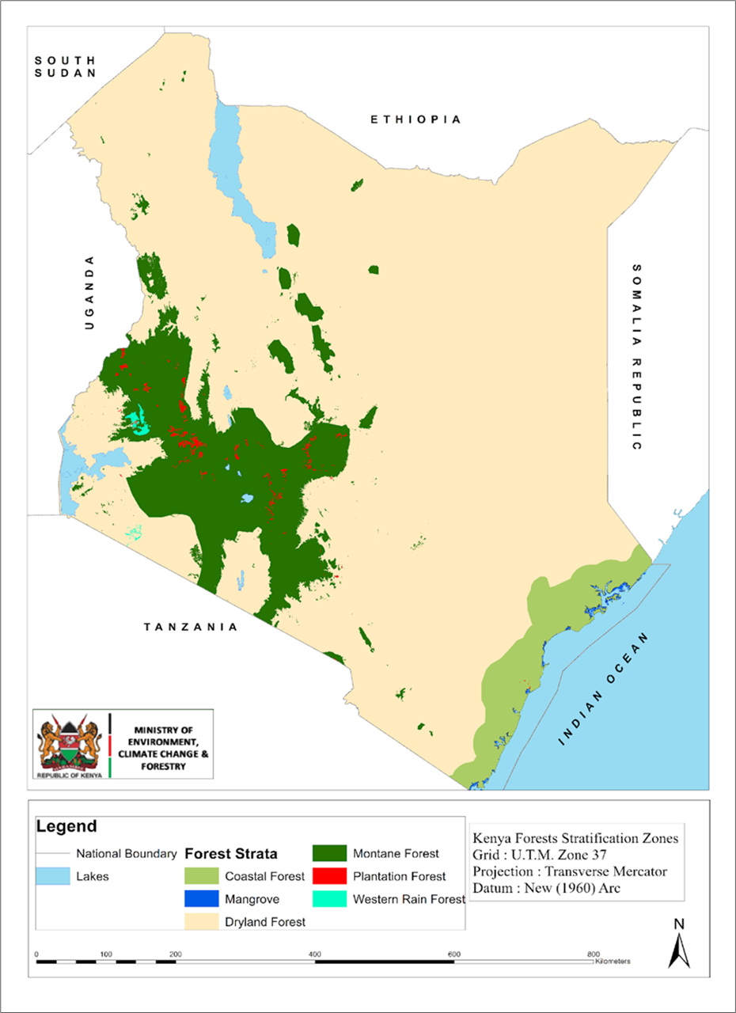
Figure 2: Spatial distribution of the forest strata
1.5.4 Forest Tenure and Governance Framework
Forest stewardship in Kenya is established under the Constitution of Kenya (2010) and the Forest Conservation and Management Act (2016). The public forest areas are mainly under the management of the Kenya Forest service and the Kenya Wildlife service and are managed with the objective of Biodiversity conservation, water catchment protection, and sustainable commercial production. Community forests are found in community lands while private forests are found in lands that re privately owned. Forests in private lands have varied roles based on the objectives of the owner and are largely the source of wood products such as poles, timber and charcoal.

Methodology

Introduction
As a primary component of the System of Environmental-Economic Accounting (SEEA) Central Framework, physical forest accounts are designed to monitor longitudinal changes in forest extent and biomass. The compilation of these physical accounts involves the integration of geospatial land-cover data and national forest inventory statistics, to ensure a precise and verifiable representation of the natural capital. By documenting opening and closing stocks alongside the flows that alter these resources within an accounting period, these accounts establish the quantitative baseline necessary for monetary valuation and the assessment of ecosystem service flows. Similarly, providing supply and use tables helps to track sources and uses of natural capital to advise policy.

The sections below explain how the specific data sets used in developing the forest accounts were obtained and integrated to generate an account. Due to limitations of data, some of the necessary calculations could not be done, specifically assigning a monetary value to some of the forest resources.

Land cover data and their sources
The forest ecosystem accounts were compiled using spatially explicit land cover datasets derived primarily from two nationally coordinated initiatives: the System for Land-based Emissions Estimation in Kenya (SLEEK) and the Improving Measurement for Payments to Reduce Emissions and Strengthen Sinks (IMPRESS) project. These initiatives provide the core geospatial inputs required for the construction of forest ecosystem extent and condition accounts, in line with the System of Environmental-Economic Accounting – Central Framework (SEEA CF) framework.

The SLEEK programme was funded by the Australian Government with the objective of establishing a comprehensive National Carbon Accounting System (NCAS) that integrates data from the forestry and agricultural sectors to enable consistent measurement, reporting, and verification (MRV) of greenhouse gas emissions and removals. The SLEEK provides a countrywide gridded dataset of satellite-based time series of LCLU data at 30m resolution for 18 years (1995, 2000, 2002, 2003, 2004, 2005, 2006, 2007, 2008, 2009, 2010, 2011, 2012, 2013, 2014, 2015 and 2018) generated by supervised classification using a random forests algorithm.

The IMPRESS on the other hand is one of the ongoing multi-partner initiatives led by the Food and Agriculture Organization of the United Nations (FAO) to strengthen Kenya’s National Forest Monitoring System (NFMS) by improving the accuracy, consistency, and timeliness of forest-related data using recent technology in forest monitoring. This FAO supported methodology relies on sample-based area estimation methodologies for monitoring forest cover and uses statistically generated points to record land cover change over time. The IMPRESS generated national land cover maps for the period 2015-2023, using a combination of satellite imagery and field data on a collect earth online platform. The IMPRESS project generated land cover statistics for years 2015 - 2023.

The two datasets were integrated to allow a complete time series dataset for the period 1990 – 2023 while data for 2024 was either projected or calculated as a final stock using mapped levels of afforestation and deforestation specifically using the latest 5-year dataset.

Emission factors for biomass assessment
To estimate biomass content in forests and associated losses and gains from deforestation and afforestation, data sets were obtained from the National Green House Gas inventory. The Data comprises Emission factors collected from field inventories that provide stocks for each of the forest strata described above and their specific canopy categories. This data has been used in developing submissions to the United Nations Framework Convention on Climate Change (UNFCCC) namely; Kenya’s Forest Reference Level and also the Biennial Transparency Report

Biomass stock changes in deforestation, forest degradation and from other sources (sustainable management, wooded grasslands. trees outside forests etc.) were used to estimate the role of tree resources for biomass supply as a source of energy.

Calculation of emissions associated with deforestation and afforestation activities was done using the stated Emission factors following IPCC guidelines.

Forest volumes in public plantations
Data on the volumes of wood for different species was obtained form the KFS. It indicates estimated volumes of wood in the forest over the recent years. This volume provides an estimate of available wood for harvesting to allow a sustainable harvesting programme. It was not possible to get wood volumes from private forests. In developing the Supply and Use tables for furniture and construction material, it was estimated that the balance of wood supply from the public plantation forests is provided by the private forests.

Food resources from the forest
Food resources form the forest were estimated based on the area of Plantation Establishment and livelihood Establishment Scheme (PELIS) for the recent years. The PELIS programme operated by the KFS allocates land to forest adjacent communities to till and plant annual crops. In these lands the communities work with KFS to plant commercial tree species (mainly Cuppresssus lusitanica and Pinus spp) and the farmers continue tending the trees as their cultivate for their crops. Commonly cultivated crops are maize, legumes, potatoes and kales.

Estimated profitability of the PELIS obtained from literature and expert judgement was K.Sh 50,000 per hectare per year and this was used to estimate the estimated income arising from crops that are grown in forests. It is noted that this estimate is lower than the realistic estimate because some indigenous vegetables growing in natural forests such as stinging nettle, amaranthus, solanum nigrum, mushrooms and a variety of insects were not estimated.

Developing Supply and Use tables for wood products
XXXXXXX

Asset Accounts for Forests

3.1 Forest Assets in Kenya

3.1.1 Forest Cover Trends and Status (1990–2024)
Overall, the forest area decreased by 342.793 ha in the period 1990 – 2024, reducing from 3,934,279 ha (6.65% of the national area) to 3,591,486ha (6.07% of the national area). Using the FAO-Forest Resource Assessment methodology that accounts for forest areas based on the land area only (without water bodies), Kenya’s forest cover decreased from 6.78% to 6.19% in the period 1990 -2024. This reduction partially reflects the manifestation of historical drivers of land cover change described in the REDD+ strategy for the period prior to 2010. However, the data indicate a gradual recovery, in the period 2016- 2024 (Figure 3), raising forest cover to 6.07%. While this suggests a positive recent trend, forest cover in 2024 remains below the levels recorded in the early 1990s

Figure 3: Gradual recovery of forest area in the period 2016-2024
In terms of canopy density, dense forest shows notable fluctuations. After declining between 1990 and 2000, dense forest area increased in 2010 but dropped again by 2019. Since 2020, dense forest has exhibited a steady increase, rising from about 2.26 million ha in 2020 to 2.29 million ha in 2024. This recent growth suggests improvements in forest protection, regeneration, or reclassification toward higher canopy density in some areas.
Moderately dense forest experienced an overall downward trend, decreasing from 0.96 million ha in 1990 to around 0.81 million ha in 2019. Although there has been some recovery after 2019, moderate forest area in 2024 (0.89 million ha) remains below its 1990 extent, indicating partial but incomplete restoration of medium-density forest classes.
Open forest has consistently declined over the entire period, falling from 0.58 million ha in 1990 to approximately 0.41 million ha in 2024. This persistent reduction suggests either conversion to non-forest land uses or transitions into higher-density forest classes, though the magnitude of dense forest gains does not fully offset the long-term losses observed in open forest.

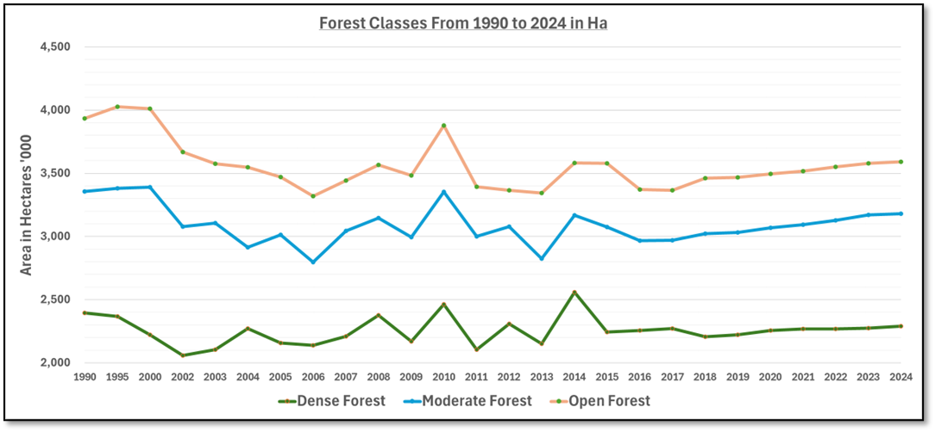
Figure 4: Forestland area trends 1990-2024
Outside the forest estate, wooded grasslands dominate the land cover but show a marked long-term decline, from 34.3 million ha in 1990 to 29.4 million ha in 2024. In contrast, other non-forest areas have expanded steadily over the same period, indicating continued pressure on forests from agriculture, settlements, and other land uses. As a result, total non-forest area has remained relatively stable in recent years but with shifting internal composition.
In summary, the data depict a long period of forest contraction in Kenya up to 2019, followed by modest recovery from 2020 to 2024. Recent gains are mainly driven by increases in dense forest, while open and moderate forests remain under pressure. Although the upward trend in forest cover is encouraging, sustained effort will be required to restore forest extent and improve canopy quality to levels observed in earlier decades.

Table 2: Status of Forest; 1990-2024
 | Area in '000 Ha
 | 1990 | 2000 | 2010 | 2019 | 2020 | 2021 | 2022 | 2023 | 2024
Canopy Density
Dense Forest | 2,394 | 2,221 | 2,464 | 2,222 | 2,256 | 2,269 | 2,269 | 2,275 | 2,289
Moderate Forest | 964 | 1,170 | 889 | 811 | 814 | 824 | 859 | 894 | 890
Open Forest | 577 | 620 | 525 | 434 | 426 | 424 | 422 | 410 | 412
Total Forest Area | 3,934 | 4,011 | 3,878 | 3,467 | 3,496 | 3,517 | 3,550 | 3,580 | 3,591
Wooded Grassland | 34,278 | 32,730 | 31,742 | 29,811 | 30,224 | 29,949 | 30,236 | 28,998 | 29,403
Other Non-Forest | 20,992 | 22,463 | 23,583 | 25,926 | 25,484 | 25,738 | 25,418 | 26,627 | 26,209
Non-Forest Area | 55,270 | 55,193 | 55,325 | 55,736 | 55,708 | 55,687 | 55,653 | 55,624 | 55,612
% Forest Cover | 6.65% | 6.77% | 6.55% | 5.86% | 5.90% | 5.94% | 6.00% | 6.05% | 6.07%
Total | 59,204 | 59,204 | 59,204 | 59,204 | 59,204 | 59,204 | 59,204 | 59,204 | 59,204

3.1.2. Forest Assets by strata
The forests of Kenya are distributed into the specific strata described in the methodology section are shown in Table 3 for the period 2016- 2024. The table shows that most of the forests of Kenya are found in the drylands (approximately 46%) followed by the montane areas (approximately 32%) and about 17% are found in the coastal and mangrove areas. The specific strata have undergone gradual changes in the area of forests and these statistics contribute to the overall change in forest area at the national level.

Table 3: Forest area by forest strata (2016-2024)
Strata | Area of forestland (‘1000 ha) in the period 2016 -2024
 | 2016 | 2017 | 2018 | 2019 | 2020 | 2021 | 2022 | 2023 | 2024
Coastal Forest | 477 | 475 | 488 | 538 | 537 | 536 | 538 | 542 | 539
Dryland Forest | 1,080 | 1,079 | 1,108 | 1,112 | 1,081 | 1,093 | 1,108 | 1,119 | 1,130
Mangrove | 65 | 65 | 67 | 67 | 67 | 66 | 67 | 67 | 67
Montane Forest | 1,569 | 1,572 | 1,620 | 1,615 | 1,625 | 1,633 | 1,644 | 1,657 | 1,659
Plantation Forest | 130 | 127 | 130 | 133 | 136 | 138 | 143 | 144 | 147
Western Rain Forest | 50 | 49 | 50 | 51 | 50 | 49 | 50 | 51 | 51
Grand Total | 3,372 | 3,367 | 3,463 | 3,467 | 3,496 | 3,517 | 3,550 | 3,580 | 3,591

Figure 5: An illustration of the proportions of forests found in different strata of Kenya

3.1.3. Spatial Distribution of Forest Assets by County
The physical asset accounts for Kenya’s forests reveal a diverse landscape of forest cover, significantly influenced by regional topography and climatic zones. An analysis of the county-level data from 2019 to 2024 demonstrates that forest cover is not uniformly distributed, with a high concentration of forest assets in the "Water Tower" regions and significant expanses of dryland forestry in the Arid and Semi-Arid Lands (ASALs).

A calculation of opening and closing stocks in forest area by counties in the last 5 years (Table 5) provides information to support policy action at the county level and his is illustrated in Figure 6. Turkana, Nandi and Makueni Counties achieved the highest levels of afforestation at 45,280ha, 33,496ha and 26,434ha respectively. The counties with the highest levels of deforestation were Narok and Turkana with 28,240ha and 21,302ha respectively. Lamu and Nyeri with large forest areas experienced no significant change in the forest areas implying the forests are stable. Lamu with a forest area of 267,054ha in 2019 had only 1,079ha in afforestation and 2,537ha in deforestation. Similarly, Nyeri with a forest area of 146,694ha in 2019 gained 8,137ha in afforestation and lost 2,377ha from deforestation. Nairobi and Mombasa counties with urban forests of 7,076ha and 1,891ha respectively did not indicate and noticeable afforestation or deforestation activities in the 5-year period.

3.1.2.2 Regional Analysis of Forest Holdings
A significant portion of the country's forest wealth is concentrated in five key counties, which have maintained their status as the primary custodians of forest land:
Samburu: Remains the leader in forest coverage, ending 2024 with 319,666 ha. It has shown remarkable stability with a slight overall increase since 2019.
- Garissa: Holds the second-largest forest area at 310,823 ha, experiencing a steady climb from 306,380 ha in 2019.
- Narok: While still a top-tier forest county (278,547 ha), Narok is notable for being one of the few large-scale forest areas to show a decline (dropping from 285,122 ha in 2019).
- Turkana: This county recorded the most significant expansion in terms of raw acreage, growing from 245,235 ha to 270,588 ha—an increase of over 25,000 ha.
- Lamu: Maintains a robust forest estate of 265,504 ha, showing consistent stability with minor fluctuations.

3.1.2.3 Emerging Growth Leaders
Several counties have demonstrated high-intensity growth, likely reflecting successful community-based or county-led greening programs:
- Kisii: Grew from 28,052 ha to 35,592 ha, a significant percentage increase for its land size.
- Kakamega: Increased its coverage from 49,310 ha to 55,930 ha, highlighting the protection of its unique tropical rainforest ecosystems.
- Migori: Showed strong gains, moving from 16,218 ha in 2019 to 21,886 ha in 2024.

It is noted that in the drier counties such as Turkana, the extensive expansion of the invasive Prosopis juliflora contributes to a rapid increase in forests but such forests are also cleared within short periods. The results also illustrate that dryland counties like Turkana, Garissa, Samburu and Makueni have a big potential for afforestation and this is compliant with the 15 billion tree strategy.

Table 4: County statistics of opening and closing stocks of forest area (2019-2024)
County | Areas of Forest in ha (2019 -2024)
 | Initial Area in 2019 | Total afforestation | Total deforestation | Closing area 2024
Baringo | 119,659 | 5,588 | 3,697 | 121,550
Bomet | 82,625 | 7,736 | 6,533 | 83,828
Bungoma | 45,961 | 6,952 | 4,745 | 48,169
Busia | 9,668 | 3,486 | 2,058 | 11,097
Elgeyo-Marakwet | 102,623 | 4,775 | 5,664 | 101,734
Embu | 42,999 | 4,045 | 2,538 | 44,506
Garissa | 312,605 | 4,345 | 3,057 | 313,894
Homa Bay | 9,298 | 4,315 | 999 | 12,613
Isiolo | 26,704 | 3,186 | - | 29,890
Kajiado | 37,073 | 429 | - | 37,503
Kakamega | 49,294 | 16,258 | 5,074 | 60,478
Kericho | 60,775 | 9,450 | 8,276 | 61,948
Kiambu | 48,554 | 929 | 3,057 | 46,426
Kilifi | 82,255 | 3,057 | 2,292 | 83,019
Kirinyaga | 41,147 | 1,499 | 644 | 42,002
Kisii | 28,555 | 6,861 | 4,655 | 30,762
Kisumu | 3,743 | 6,348 | 2,917 | 7,174
Kitui | 113,733 | 3,856 | 3,596 | 113,993
Kwale | 54,850 | 1,269 | 929 | 55,189
Laikipia | 58,923 | 3,586 | 3,486 | 59,023
Lamu | 267,054 | 1,079 | 2,537 | 265,595
Machakos | 14,853 | 5,464 | 1,998 | 18,319
Makueni | 68,182 | 26,434 | 11,777 | 82,839
Mandera | 4,483 | 539 | 2,487 | 2,535
Marsabit | 35,222 | 9,650 | 1,538 | 43,333
Meru | 99,290 | 5,354 | 1,358 | 103,286
Migori | 14,483 | 9,774 | 1,538 | 22,718
Mombasa | 1,891 | - | - | 1,891
Murang'a | 61,145 | 11,009 | 11,129 | 61,025
Nairobi | 7,076 | - | - | 7,076
Nakuru | 103,734 | 6,828 | 6,818 | 103,744
Nandi | 70,774 | 33,496 | 16,362 | 87,908
Narok | 285,200 | 14,440 | 28,240 | 271,400
Nyamira | 21,889 | 8,026 | 7,563 | 22,353
Nyandarua | 88,550 | 12,401 | 7,452 | 93,499
Nyeri | 146,694 | 8,137 | 2,377 | 152,453
Samburu | 304,088 | 6,973 | 6,643 | 304,418
Siaya | 7,076 | 2,567 | - | 9,643
Taita Taveta | 29,667 | - | - | 29,667
Tana River | 58,553 | 14,215 | 9,875 | 62,893
Tharaka-Nithi | 47,072 | 429 | - | 47,502
Trans Nzoia | 43,369 | 9,599 | 6,188 | 46,780
Turkana | 227,798 | 45,280 | 21,302 | 251,776
Uasin Gishu | 44,850 | 9,255 | 2,998 | 51,108
Vihiga | 14,853 | 539 | - | 15,392
Wajir | 8,928 | 999 | 2,058 | 7,869
West Pokot | 59,664 | 1,968 | 1,968 | 59,664
Total | 3,467,483 | 342,427 | 218,424 | 3,591,486

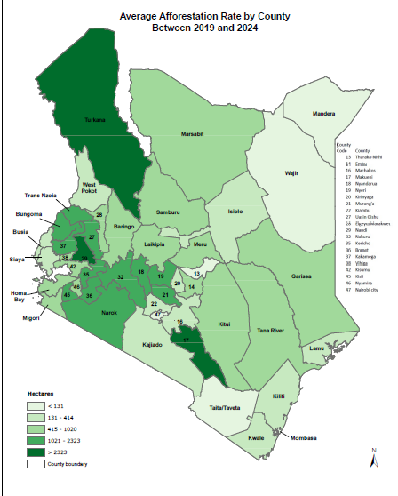 | 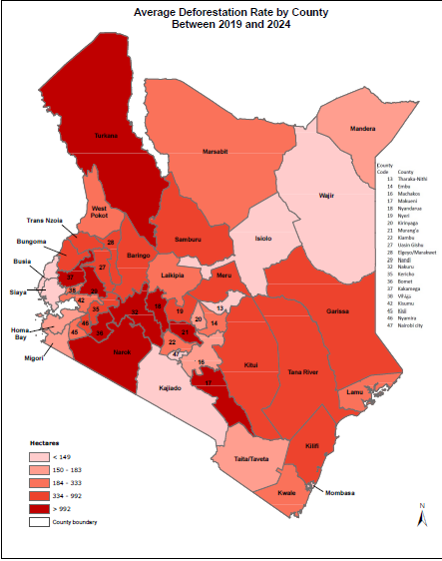
Figure 6: An illustration of the area of afforestation and deforestation by counties in the 5-year period (2019-2024)

Table 5 Top 10 High-Growth Counties by % of county area (2019–2024)
Rank | County | 2019 Forest (ha) | 2024 Forest (ha) | Percentage Growth (%)
1 | Kisumu | 4,164 | 6,411 | 53.96%
2 | Migori | 16,218 | 21,886 | 34.95%
3 | Homa Bay | 8,547 | 11,496 | 34.50%
4 | Kisii | 28,052 | 35,592 | 26.88%
5 | Siaya | 7,232 | 8,843 | 22.28%
6 | Uasin Gishu | 38,133 | 44,435 | 16.53%
7 | Busia | 9,862 | 11,275 | 14.33%
8 | Kakamega | 49,310 | 55,930 | 13.43%
9 | Nandi | 69,692 | 77,595 | 11.34%
10 | Marsabit | 36,818 | 40,677 | 10.48%

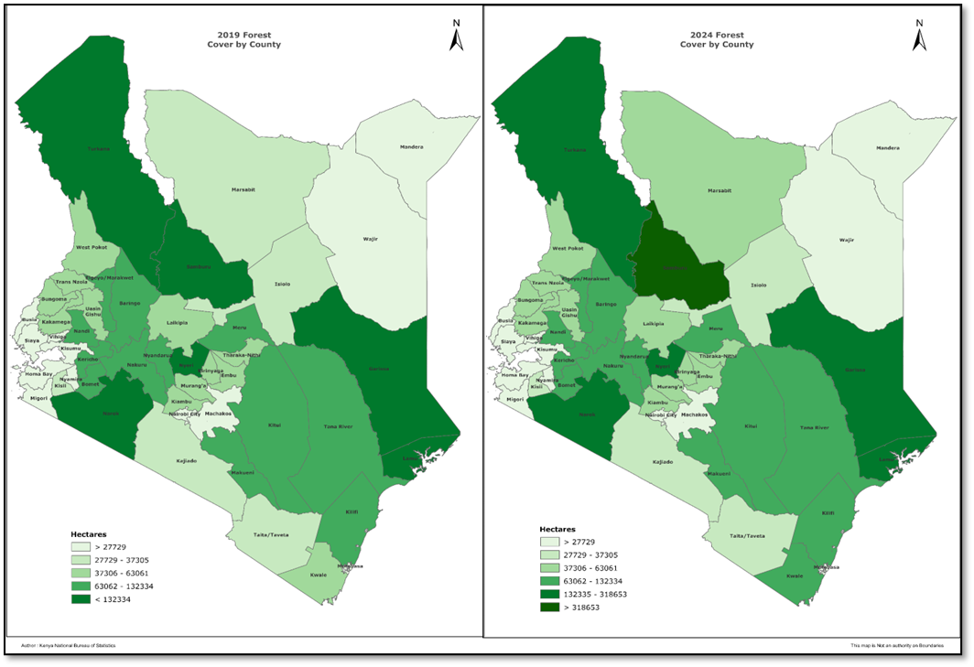

3.2. Forest Opening and Closing Stocks

 | 2019 | 2020 | 2021 | 2022 | 2023
Afforestation | 56,035 | 56,087 | 92,426 | 98,275 | 39,604
Deforestation | 27,696 | 35,054 | 58,953 | 68,939 | 27,782
Land Category | 2019 | 2020 | 2021 | 2022 | 2023 | 2024
Opening Stock (ha) | 3,467,483 | 3,495,823 | 3,516,855 | 3,550,328 | 3,579,664 | 3,591,486
Additions | 56,035 | 56,087 | 92,426 | 98,275 | 39,604
Reductions | 27,696 | 35,054 | 58,953 | 68,939 | 27,782
Closing Stock (ha) | 3,495,823 | 3,516,855 | 3,550,328 | 3,579,664 | 3,591,486

3.3 Forest Biomass and Volume Stocks
Forest stocks are presented here in two units; volume for public plantations and biomass for the natural forests. The volumes relate to exotic plantations that are planted under a commercial forestry programme comprising about 152,000 ha and is managed by the Kenya Forest Service.

3.3.1. Volumes of standing wood
Forest volumes were estimated based on wood stocks inventoried in the public plantations managed by the Kenya Forest Service. The service manages these plantations to meet the national demands for wood products and these plantations are expected to be harvested and replanted under a maximum 30-year rotation implying that about 5,000ha are planned for harvesting annually. Table 3 illustrates that there was about 26.333million m3 of wood stocks available in the public plantations of Kenya and this wood stock is in various stages of growth. The gradual increase in the stocks is associated with a reducing backlog in the plantation programme noting that the planting programme was enhanced in the last 10 years. The results imply that these forests can support a sustainable exploitation of 5000ha (with a stocking of about 200m3 at maturity) to annually supply 1,000,000m3 of wood/sawlog resources for Kenya’s domestic furniture and construction market and also for export.

Cupressus lusitanica is the species with the largest stock of commercial wood products accounting for over 44% of the total stocks available in the forest and this is followed by Pinus patula at 22%. Eucalyptus species and other species (Vitex keniensis, Ocotea usambarensis, Juniperus procera and Grevillea robusta) are some of the other commercial forests found in the public plantation forests of Kenya. Figure 3 illustrates the commutative contribution of the specific species to the national wood stocks in public plantations of Kenya.

Since data for wood stocks in private plantations was not available, we assumed that these plantations can supply half of these wood resources implying a capacity of the forests of Kenya to supply 1.5 million M³ of wood resources to support the furniture and construction industries annually.
Table 6: Volume of wood stocks for different commercial forestry species (2016-2024)
Species | Wood stocks in 1000, M3 for different species in the public forests under KFS
 | 2016 | 2017 | 2018 | 2019 | 2020 | 2021 | 2022 | 2023 | 2024
Cupressus lusitanica | 10,980 | 10,765 | 10,765 | 10,980 | 11,286 | 11,440 | 11,746 | 11,746 | 11,746
Eucalyptus spp | 1,718 | 1,684 | 1,684 | 1,718 | 1,766 | 1,790 | 1,838 | 1,838 | 1,838
Pinus patula | 5,468 | 5,361 | 5,361 | 5,468 | 5,621 | 5,697 | 5,850 | 5,850 | 5,850
Others | 6,448 | 6,322 | 6,322 | 6,448 | 6,628 | 6,718 | 6,899 | 6,899 | 6,899
Total stocks | 24,614 | 24,133 | 24,133 | 24,614 | 25,301 | 25,645 | 26,333 | 26,333 | 26,333

Figure 4: A cumulative bar graph showing the contribution of different commercial tree species in the wood stocks of public plantations

3.3.2. Above ground biomass stocks
The biomass stocks in forests were estimated from the specific emission factors that have been used for the specific strata in developing the Kenya Forest reference Level for REDD+ and the Biennial Transparency Report for stock at a time, deforestation and afforestation. It is noted that montane forests with an average stock of 132.79 T/ha compared to dryland forests with and average stock of 52.66 T/ha have a higher closing stock of AGB (201,687,323 Tonnes) despite their relatively smaller areas compared to dryland forests (55,600,040 Tonnes). This implies that a deforestation of a montane forest and Western rain forests which have bigger stocks per hectare results to more biomass losses compared with forests that have lesser biomass stocks.

A total of 20,191,868 Tonnes of above ground biomass were lost from deforestation activities in the forests of Kenya implying an annual loss of 4,038,374 Tonnes. Most of this biomass loss is attributed to charcoal and fuelwood.

Table 7: Opening and closing stocks of Above ground biomass in the recent years (2019-2024)
Strata | Above ground Biomass (Tonnes) in the period 2019 - 2024
 | Opening stock in 2019 | Increase from Afforestation | Decrease from Deforestation | Closing stock in 2024
Coastal Forest | 57,331,754 | 36,689 | 1,089,860 | 56,278,582
Dryland Forest | 59,345,568 | 368,647 | 4,114,174 | 55,600,040
Mangrove | 1,092,136 | - | 39,088 | 1,053,049
Montane Forest | 216,266,758 | 1,527,875.27 | 16,107,311 | 201,687,323
Western Rain Forest | 11,116,445 | 55,441 | 830,086 | 10,341,800
Grand Total | 345,152,661 | 1,988,651 | 22,180,519 | 324,960,794

The loss in forest biomass was converted to CO2eq using IPCC guidelines and the resultant emissions estimated at a price of 5USD. The annual loss in economic value from deforestation was estimated at 36,963,723 (Table 6) and the total loss in the 2019 – 2024 period was estimated at 184,818,614. Just like explained in the biomass section, the greatest economic loss is felt when forests with higher stocks (Montane and western rain) are deforested.

Table 8: Economic loss in USD due to deforestation in the period (2019-2024)
Strata | Economic loss (USD) due to deforestation
 | Annual Loss | Total loss (2019-2024)
Coastal Forest | 1,814,966 | 9,074,831
Dryland Forest | 6,454,792 | 32,273,962
Mangrove | 67,361 | 336,807
Montane Forest | 25,125,227 | 125,626,135
Plantation Forest | 2,166,404 | 10,832,022
Western Rain Forest | 1,334,972 | 6,674,858
Grand Total | 36,963,723 | 184,818,614

3.3.3. Biomass supply by tree resources
Based on estimated rates of deforestation and forest degradation in the period 2019-2024, calculation of estimated supply of biomass resources mainly used to support charcoal and firewood in Kenya. The Table 9 shows that a total of 34,060,905Tonnes is supplied by tree resources annually supporting energy requirements for industrial (e.g. tea factories) and domestic requirements. The woodlands of Kenya estimated at over 40% of the national land area are the main sources of biomass and this result agrees well with the results of land cover analysis provided in the land accounts that show that these areas are rapidly converting into open grasslands and annual croplands.

Table 9: Average annual biomass supply from tree resources in the period 2019-2024)
Sources of Biomass | Average annual Biomass supply (Tonnes) in the period 2019 - 2024
Deforestation | 4,038,374
Forest degradation | 3,028,780
From agroforestry | 6,057,560
From woodlands | 10,095,934
From plantation forests | 744,323
From private forests | 10,095,934
Total | 34,060,905

3.3.4. Forests as Food sources
The forests of Kenya are a source of food resources. Under the Plantation and Livelihood Improvement scheme, farmers are allowed to farm in the forests and produce food while tending for the young seedlings that are established in commercial plantation areas. Table 10 shows that the forest estate accounts for domestic incomes of Kenya Shillings 182 – 430 million through farming of crops in forests. It is noted that this acounting is not exhaustive because a number of traditional vegetables, insects and other food products were not included in this analysis

Table 10: Estimated area and income related to food resources obtained from forests (2016-2024)
Types of food | Area (ha) supporting production of different types of foods in forests
 | 2015 | 2016 | 2017 | 2018 | 2019 | 2020 | 2021 | 2022 | 2023 | 2024
Maize | 3,910 | 3,814 | 4,483 | 4,483 | 3,814 | 2,859 | 2,382 | 1,427 | 1,427 | 1,427
potatoes | 1,564 | 1,526 | 1,793 | 1,793 | 1,526 | 1,144 | 953 | 571 | 571 | 571
Cabagae and Kales | 1,564 | 1,526 | 1,793 | 1,793 | 1,526 | 1,144 | 953 | 571 | 571 | 571
Peas | 782 | 763 | 897 | 897 | 763 | 572 | 476 | 285 | 285 | 285
others | 782 | 782 | 782 | 782 | 782 | 782 | 782 | 782 | 782 | 782
Total | 8,601 | 8,410 | 9,747 | 9,747 | 8,410 | 6,500 | 5,545 | 3,636 | 3,636 | 3,636
 | Income (K.sh in millions) from food resources obtained in forests
Maize | 195 | 191 | 224 | 224 | 191 | 143 | 119 | 71 | 71 | 71
potatoes | 78 | 76 | 90 | 90 | 76 | 57 | 48 | 29 | 29 | 29
Cabagae and Kales | 78 | 76 | 90 | 90 | 76 | 57 | 48 | 29 | 29 | 29
Peas | 39 | 38 | 45 | 45 | 38 | 29 | 24 | 14 | 14 | 14
others | 39 | 39 | 39 | 39 | 39 | 39 | 39 | 39 | 39 | 39
Total | 430 | 421 | 487 | 487 | 421 | 325 | 277 | 182 | 182 | 182

Supply and Use Tables

Physical Supply and Use Table
Table 6: Physical Supply Tables (2021-2024)

Domestic Production | Kgs
Product | 2021 | 2022 | 2023 | 2024
Edible Forest Products | 17,265,068 | 19,777,223 | 17,151,119 | 19,462,900
Non-wood forest products | 5,783,292 | 3,212,223 | 3,212,223 | 4,041,000
Hardwood and soft wood | 38,146,154 | 42,161,538 | 177,792,308 | 690,200,000
Wood and products of wood | 4,844,890,550 | 5,587,364,222 | 5,587,364,222 | 4,904,405,200
Firewood and Charcoal | 24,611,772,667 | 36,331,664,000 | 84,148,824,000 | 86,578,645,333
Furniture | 584,133,059 | 571,912,514 | 751,027,995 | 1,414,281,399
Total | 30,101,990,790 | 42,556,091,720 | 90,685,371,867 | 93,611,035,832
Imports | Kgs
Product | 2021 | 2022 | 2023 | 2024
Edible Forest Products | 533,501 | 327,796 | 308,847 | 298,116
Non-wood forest products | 243,983 | 271,137 | 435,905 | 608,804
Hardwood and soft wood | 384,617 | 376,571 | 494,508 | 931,222
Wood and products of wood | 129,384,896 | 123,861,600 | 134,694,523 | 181,498,667
Firewood and Charcoal | 1,189,819 | 1,551,412 | 2,074,470 | 221,407
Furniture | 53,690,919 | 37,532,095 | 25,291,410 | 27,290,005
Total | 185,427,734 | 163,920,611 | 163,299,663 | 210,848,221

Table 7: Physical Use Tables (2021 - 2024)

Industrial | Kgs
Product | 2021 | 2022 | 2023 | 2024
Edible Forest Products | - | - | - | -
Non-wood forest products | - | - | - | -
Hardwood and soft wood | - | - | - | -
Wood and products of wood | - | - | - | -
Firewood and Charcoal | 562,796,367 | 830,793,499 | 1,924,228,011 | 1,979,789,675
Furniture | - | - | - | -
Total | 562,796,367 | 830,793,499 | 1,924,228,011 | 1,979,789,675
Households | Kgs
Product | 2021 | 2022 | 2023 | 2024
Edible Forest Products | - | - | - | -
Non-wood forest products | - | - | - | -
Hardwood and soft wood | - | - | - | -
Wood and products of wood | - | - | - | -
Firewood and Charcoal | 87,672,526,291 | 129,421,347,992 | 299,756,546,367 | 308,412,103,250
Furniture | - | - | - | -
Total | 87,672,526,291 | 129,421,347,992 | 299,756,546,367 | 308,412,103,250
Exports | Kgs
Product | 2021 | 2022 | 2023 | 2024
Edible Forest Products | 69,759 | 80,060 | 73,405 | 45,067
Non-wood forest products | 6,810,287 | 5,860,162 | 6,088,069 | 8,056,175
Hardwood and soft wood | 352,974 | 360,703 | 991,671 | 4,388,527
Wood and products of wood | 8,354,522 | 18,627,561 | 23,315,840 | 48,910,195
Firewood and Charcoal | 285,590 | 344,022 | 506,843 | 179,433
Furniture | 266,222 | 107,865 | 127,648 | 115,530
Total | 16,139,354 | 25,380,373 | 31,103,476 | 61,694,927

Monetary Supply and Use Tables
XXXXXX

Timber and Non-timber Forest Products Physical and Monetary Flow Account (PFA)
XXXXXX

Scenario Analysis
XXXXXX

Conclusions & Emerging Issues
Kenya has taken significant strategic steps towards institutionalizing environmental-economic accounting.

5.1 Emerging Issues
5.1.1 Challenges in Compiling Forest Asset Accounts in Kenya

The integration of the System of Environmental-Economic Accounting (SEEA) into Kenya’s national statistical framework is a cornerstone of the National Plan for Advancing Environmental-Economic Accounting (NP-AEEA) 2025–2028. However, several persistent challenges continue to constrain the accurate and consistent compilation of forest asset accounts.
- Data Scarcity and Methodological Constraints: A major challenge is the limited availability of high-resolution, long-term data required to measure forest degradation as distinct from deforestation. While satellite imagery is effective for tracking land-cover change, detecting gradual reductions in forest biomass and structural quality remains technically demanding. In addition, significant data gaps persist for private and community forests, which constitute a substantial share of Kenya’s tree cover but are not monitored as systematically as public gazetted forests.
- Limited Visibility of Non-Market Values: Conventional economic accounting frameworks tend to underrepresent the full contribution of forests by excluding non-market and subsistence uses. Forest products such as fuelwood, medicinal plants, and charcoal produced and consumed within informal markets are often omitted from official statistics. As a result, the recorded economic contribution of the forestry sector understates its true role in livelihoods, energy supply, and rural economies.
- Complexity in Ecosystem Service Valuation: Valuing regulating ecosystem services, including water regulation, flood control, and climate moderation, presents both scientific and economic challenges. The benefits derived from these services vary across locations and socio-economic groups, making it difficult to establish standardized valuation parameters that are applicable across Kenya’s diverse forest ecosystems.
- Institutional and Governance Constraints: The development of comprehensive forest asset accounts requires coordinated data sharing and collaboration among multiple institutions. In practice, fragmented data systems, overlapping mandates, and inconsistent methodologies hinder the integration of environmental information into national economic accounts. In addition, illegal logging and other unrecorded extractions reduce forest assets without being captured in formal statistical systems.
- Technical and Financial Capacity Limitations: Producing SEEA-compliant forest accounts demands specialized expertise spanning environmental science, remote sensing, and macroeconomic accounting. Capacity constraints within public institutions, coupled with the high cost of conducting regular forest inventories needed to validate remote-sensing outputs, remain significant barriers to sustained and high-quality forest accounting.

5.2 Recommendations
- Implement NP-AEEA (2025-2028): Operationalize the National Plan to ensure forest accounts are produced regularly, enabling progress tracking and accountability.
- Strengthen Coordination (TWG): Empower the Technical Working Group to harmonize methodologies and facilitate data sharing across agencies (KFS, KNBS, MoECCF).
- Build Technical Capacity: Develop specialized expertise in SEEA-compliant accounting across environmental science and economics
- Enhance Data Quality: Invest in remote sensing validation and better monitoring of private/community forests to capture the full scope of assets and invest in regular forest inventories to validate remote-sensing outputs.
- Integrate into Policy: Link findings to macro-fiscal models (KENMOD) to assess climate shocks and support green fiscal measures.
- Regular Reporting Cycle: Forest accounts will be produced regularly, enabling progress tracking and accountability in natural resource governance
- Continuous Refinement: Opportunities for methodology enhancement, data quality improvement, and institutional capacity strengthening

5.3 Conclusions
XXXXXXX.

Annexes

Assumptions
- Sofasets are worth around KSh 55,000 weight assumed to be 55kgs
- The bamboo coffee table is 7kg per table
- Black bed worth 12k assumed to be 25kgs
- Flash door assumed to be 10kgs
- Normal stool is assumed to be 5kg
- Table stool with bamboo sticks and glass top assumed to be 8kgs
- Shoe rack worth around KSh 300 assumed to be 3kgs
- Hard wood stool worth KSh 1,000 assumed to be 5kg
- Walking stick assumed to be 0.5 kg each
- Timber assumption is that the dimension is 6*1*12 ft assumed to be 12kg each.
- Kenya exports most of softwoods, and as such the density of softwoods was assumed to be 650 kg/m3 and that of Hardwoods which are mostly imported to be 800 kg/m3
- For a bed costing KES 3,000 to 7,000 the weight was assumed to be 12 kgs
- For a bed costing KES 20,000-30,000 the weight was assumed to be 30 kgs
- In Physical-supply, to estimate the Domestic production of furniture; 2018 CIP data was used, where the value of furniture(Formal) from 2018 CIP report was estimated as 11,865,900,000. Assuming 1 M3 of furniture has a market value of Ksh 30,000, then you can get the volume. The formal sector accounts for about 30%, then estimate 100% and convert the amount into KGs, where 1 m³ = 1000 Kg.

Notes:
- For model food crop coverage out of the PELIS areas, maize is apportioned 10%, potatoes 20%, cabbage 20%
- There is a need to adjust the informal figures upwards to ensure it is a true representation of the population.
- For Items with a unit measure of pieces, mass was calculated by computing the unit price per kg of a known item that had mass recorded. Once done, the unit price per kg is used to calculate the mass of the unknown item by working backwards from its value.
- Area under plantation data is only available for 2021. Stock for the other years was extrapolated.
- There are currently 326 licenses given for grazing, with charges being KSh 100 per head of livestock. Total income was calculated by estimating daily livestock in the forests multiplied by a factor of 3 to account for those who may bring in more than what was agreed.
- The category of “Other products” is to be included in the table.

https://www.dfat.gov.au/sites/default/files/kenya-system-land-based-emissions-estimation-mtr-man-resp.pdf
https://redd.unfccc.int/files/national_frl_report_for_redd__in_kenya.pdf
https://unfccc.int/documents/645092
https://www.ipcc-nggip.iges.or.jp/public/2019rf/pdf/4_Volume4/19R_V4_Ch02_Generic%20Methods.pdf
https://www.kefri.org/assets/publications/extension/Contribution%20of%20pelis%20in%20increasing%20tree%20cover%20and%20community%20livelihoods%20in%20Kenya.pdf
https://www.fao.org/gfoi/resources/videos/video-detail/insight-into-the-global-forest-resources-assessment-process/en
https://www.un-redd.org/sites/default/files/2022-05/NATIONAL%20REDD%2B%20STRATEGY%202022.pdf
https://redd.unfccc.int/media/kenya_national_frl_report-_august_2020.pdf
https://unfccc.int/documents/645091
Chapter 2: Generic Methodologies Applicable to Multiple Land-Use Categories. https://www.ipcc-nggip.iges.or.jp/public/2006gl/pdf/4_Volume4/V4_02_Ch2_Generic.pdf
https://www.kefri.org/assets/publications/extension/Contribution%20of%20pelis%20in%20increasing%20tree%20cover%20and%20community%20livelihoods%20in%20Kenya.pdf

